Name: Amr Mohamed Eslayed Fouda
Email : amr.fouda.284@gmail.com
Task 2 :
- Checking DNS

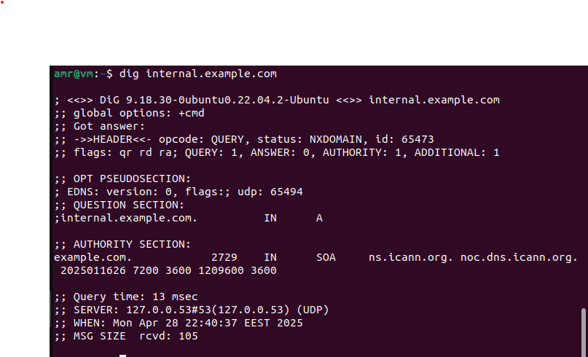
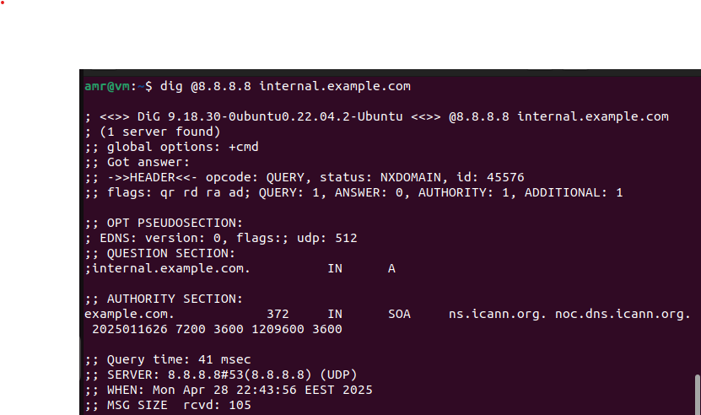
- Checking reachability to server:
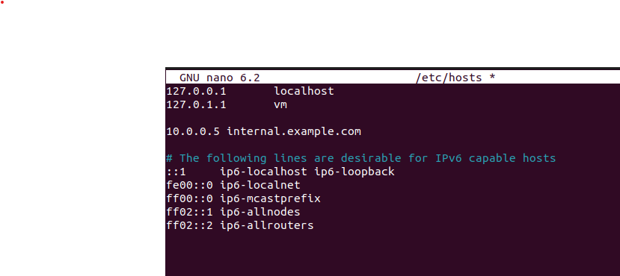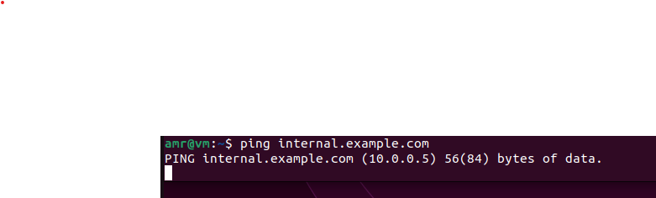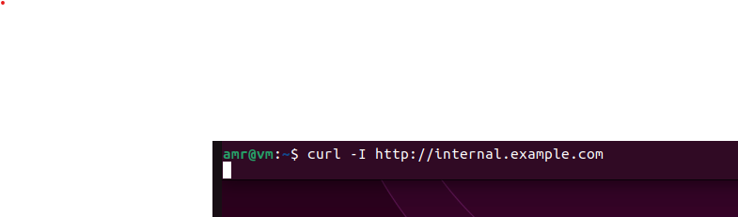

sudo netstat -tuln | grep ':80\|:443'
or
sudo ss -tuln | grep ':80\|:443'

